

**An experimental investigation on effects of attaching winglets**

Course instructor:

**Dr. M. Mani**

Teacher assistant:

**Mr. Kazemi**

Groupe Number 2

Winter 2020

Contents

Introduction 3

2D airfoil theory 4

Airfoil as infinite wing Vs. Finite wing 4

Important Aerodynamic Basics 5

LAMINAR AND TURBULENT FLOW 6

References 10

Literature Review 12

Background 12

References 24

Methods Candidate to Use 28

Surface Pressure Distributions 28

Lift Characteristics 28

Drag Characteristics 29

Lift to Drag Ratio 29

Induced Drag 29

Experimental Setup 30

Results, Discussion and Conclusion 30

Clean Wing 31

Wing with one-sided winglet 32

Wing with double-sided winglet 33

Comparison and discussion 34

**List of Figures**

Figure 1- An airfoil section 4

Figure 2- Airflow over an airfoil 5

Figure 3- Laminar and Turbulent Boundary Layer 6

Figure 4- the picture is from Van Dyke’s Album of Fluid Motion depict low speed flow over a lifting wing of finite span. 8

Figure 5- Vortex side view (Van Dyke’s Album of Fluid Motion) 8

Figure 6- Vortex top view (Van Dyke’s Album of Fluid Motion) 8

Figure 7- Vortices back view (Van Dyke’s Album of Fluid Motion) 9

Figure 8- Cp contours at different location (looking upstream from back) 10

Figure 9- This example shows how large an impact winglet can make on the diffusion of vortices (Aviation Partners, Inc.). 13

Figure 10- The original design for a set of winglets carefully designed by Whitcomb and his team at Langley (Richard Whitcomb, NASA Langley Research Center). 14

Figure 11 The Learjet Model 28 with its newly designed winglets (NASA Langley Research Center, UID: SPD-NIX-EL-1997-00215). 15

Figure 12 Angles related to wing which affect the aerodynamics function of airplane: Sweep, can’t and twist angle (Weierman & Jacob, 2010) 21

Figure 13 Winglet (a) and C-winglet (b) )**[46]** 22

Figure 14- Winglet flow simulation 24

Figure 15- Paneling of the Wing Surface 28

Figure 16- clean wing plotted data 31

*Figure 17- Clean Wing* 31

Figure 18-one-sided winglet 32

Figure 19- one-sided winglet plotted data 32

Figure 20- wing with one-sided winglet 32

Figure 21- double-sided winglet plotted data 33

Figure 22-wing with double-sided winglet 33

Figure 23-double-sided winglet 33

Figure 24- Cl-alpha comparison 34

Figure 26-- Cd-alpha comparison 35

Figure 27-CL/Cd-alpha comparison 35

# Introduction

Thin airfoil theory was developed in Germany throughout ward war II. I am far away from the only tractable means of obtaining analytical solutions for lift and moments on an airfoil. However, thin airfoil theory holds just for thin airfoils at little angles of attack. However, this can be not as restrictive as it seems as a result of several airplanes over the past years have comparatively thin airfoils and cruise at comparatively little angles of attack.

Since the 1960s, the arrival and development of the high-speed computer allowed elaborate numerical solutions supported the circulation theory of carrying, solutions for the carry on a body of arbitrary form and thickness at any angle of attack.

A device section, an essential part of a wing, has its primary task as a carry generator. The correct functioning of the device is the necessity of the satisfactory performance of the lifting surface. An airfoil formed body is enraptured through a fluid produces aerodynamic forces. The part of force perpendicular to the direction of motion is termed lift. The element parallel to the direction of motion is termed Drag. The lift made is primarily the result of its Angle of Attack and shape. When directed at an acceptable angle, the airfoil deflects the oncoming air leading to a force on the airfoil within the direction opposite to the deflection. This force is thought of like force and might be resolved into two components lift and drag.

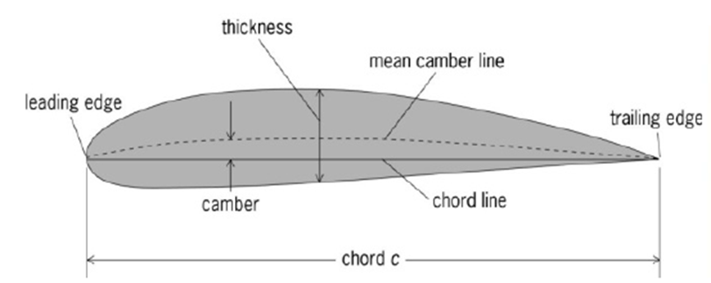

Figure 1- An airfoil section

## 2D airfoil theory

The basic equations necessary for the calculation of airfoil lift and moments with an application to symmetric airfoils and dealing with thin airfoils are first important knowledge in aerodynamics; for such a case, the airfoil are often simulated by a vortex sheet placed on the camber line. The purpose is to calculate the variation of γ(s) such that the camber line becomes a streamline of the ﬂow and such that the Kutta condition is satisﬁed at the trailing edge; that is, γ(TE) = 0. Once we have found the particular γ(s) that satisﬁes these conditions, then the total circulation around the airfoil is found by integrating γ(s)from the leading edge to the trailing edge. In turn, the lift is calculated from via the Kutta-Joukowski theorem. Kutta-Joukowski theorem says that for a closed two-dimensional body of arbitrary shape, the lift per unit span is L=.

## Airfoil as infinite wing Vs. Finite wing

A finite wing could be a three-dimensional body, and consequently the flow over the finite wing is three-dimensional; there's an element of flow within the span wise direction.

The physical mechanism for generating lift on the wing is the existence of a high on the bottom surface and a low pressure on the top surface. the net imbalance of the pressure distribution creates the lift. As a by-product of this pressure imbalance, the flow close to the wing tips tends to twist round the tips, being forced from the high-pressure region simply beneath the guidelines to the low-pressure region on top. This flow round the wing tips is shown within the front view of the wing. As a result, on the top surface of the wing, there's usually a span wise element of flow from the tip toward the wing root, causing the streamlines over the top surface to bend toward the root. On the bottom surface of the wing, there's usually a span wise element of ensue the foundation toward the tip, inflicting the streamlines over the bottom surface to bend toward the tip. Clearly, the flow over the finite wing is three-dimensional, and therefore it might be expected the aerodynamic properties of such a wing to differ from those of its airfoil sections.

The tendency for the flow to “leak” around the wing tips has another vital result on the aeromechanics of the wing. This flow establishes a circulatory motion that trails downstream of the wing; that's, a trailing vortex is made at each wing tip.

The aerodynamics of finite wings is analyzed victimization the classical lifting line model. this easy model permits a closed-form resolution that captures most of the physical effects applicable to finite wings. The model is based on the horseshoe-shaped vortex that introduces the conception of a vortex wake and wing tip vortices. The downwash elicited by the wake creates an induced drag that didn't exist within the two-dimensional analysis.

## Important Aerodynamic Basics

**THE BOUNDARY LAYER**

The friction of the air on the walls of a body around that it circulates slows down the flow among a thin layer adhering to the walls. This layer is thought as "boundary layer “.

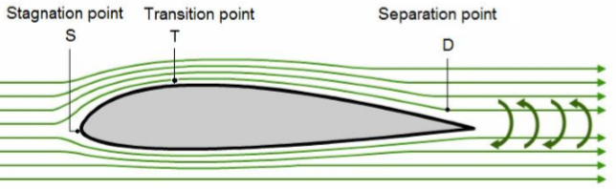

Figure 2- Airflow over an airfoil

The existence of the boundary layer is because of the consistence of the air, that isn't an ideal gas. throughout the flow, some molecules of travel on the side and others on the lower surface of the body and therefore the following ways area unit obtained delimited by:

**• The stagnation purpose (S):**

The boundary layer exists as soon as there's a flow. It begins at the stagnation purpose "A" on the side similarly as on the lower surface and the flow is at first laminar. within the stagnation purpose the overall pressure is exerted. it's a high-pressure area.

**• The transition purpose (T):**

At some extent “T” called the “transition point”, the flow becomes turbulent. The boundary layers from the higher and lower surface meet at the edge and type the wake

**• The separation purpose (D):**

As from the transition purpose T the flow undergoes changes; the airflows don't seem to be parallel any longer, and flow in a very disordered manner. this alteration corresponds to a little increase in thickness of the boundary layer. flow therefore starts from the transition purpose to the separation purpose “D”.

**Boundary Layer**

The existence of the boundary layer was discovered by noting that fine dust which was on the wings of a plane did not disappear in flight or rain drops move slowly on the walls of the airframe. The boundary layer starts from the stagnation point to the trailing edge with a variation in thickness of about a few millimeters to a few centimeters. In this thin layer, very significant forces of viscosity are present as well as large speed variations when moving away perpendicularly from the skin. Conventionally the boundary layer thickness is defined by the distance on the wall from which the rate of flow is equal to v = 0.99 v0 (v0 being the infinite speed at the normal of the skin).

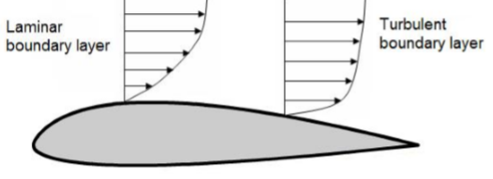

Figure 3- Laminar and Turbulent Boundary Layer

## LAMINAR AND TURBULENT FLOW

**Laminar flow:**

The initial flow of the boundary layer is laminar it is located between the stagnation point and the transition point. Within the boundary layer the airflows are parallel and slide over one another. If we look at the flight path vectors of a laminar layer, it is seen that they go from a value equal to zero to a value close to the rate of flow. All these vectors are parallel to one another.

**Turbulent flow:**

As from the transition point T the flow undergoes changes; the airflows are not parallel any more, and flow in a disordered manner. This change corresponds to a small increase in thickness of the boundary layer. Turbulent flow thus starts from the transition point to the separation point “D”. At the separation point the boundary starts to detach, the particles close to the skin have their movement reversed thus causing the formation of vortices (resulting in a significant increase in drag).

**FREE STREAM FLOW**

A flow is taken into account to be steady if its properties in each purpose has no modification with time. Let us consider an ideal fluid: If the molecules of the fluid do not exert any friction between them or the skin of the body, i.e., there is a complete absence of friction and that the volume of the fluid, independent of its size, is not affected in its movement, the flow is considered to be steady. Change within the flow with respect to time: The pressure P and speed v at an equivalent point vary continuously in an exceedingly disorderly manner. The flow is "unsteady ". These types of flow in aerodynamics will be avoided. They give rise to energy dissipations (vortices). Generally, a particle can have 3 types of movement: rotation, translation and deformation When there is no rotational movement of the particles, it is said that the flow is laminar. When there is rotation of the fluid particles, it is said that there is a vortex.

**RELATIVE AIRFLOW**

Relative airflow could be a term used to describe the direction of the flow with relation to the wing. In other texts, it's typically referred to as relative wind. If a wing is moving forward and downward, the relative airflow is upward and backward. If the wing is moving forward horizontally, the relative airflow moves backward horizontally. The flight path and the relative flow are, therefore, invariably parallel however travel in opposite directions. Relative airflow is made by the motion of the airplane through the air. it's conjointly created by the motion of air past a stationary body or by a mix of both. Therefore, on a take-off roll, a plane is subject to the relative airflow created by its motion on the bottom and conjointly by the moving mass of air (wind). In flight, however, solely the motion of the plane produces a relative airflow. The direction and speed of the wind don't have any impact on relative airflow.

**Finite Wing Effects**

Knowing the potential speeds, speed can be calculated in magnitude and direction, at all external points of the airfoil. Vortices are formed when the boundary layer separates from the airfoil. These vortices cause a change in speed in the flow known as designated speed "ω". Aerodynamic deflection at a point is the angle "ε" formed by the rate of the flow with infinite upstream speed.

**Wingtip Vortices**

Wingtip vortices are tubes of circulating air which are left behind by the wing as it generates lift. One wingtip vortex trail from the tip of each wing. The cores of vortices spin at very high speed and they are regions of very low pressure. The cores of wingtip vortices are sometimes visible because the condensation of water vapor in the very low pressure.

Wingtip vortices are related to induced drag, an essentially unavoidable side-effect of the wing generating lift. Managing induced drag and wingtip vortices and choosing the best wing planform for the mission is critically vital in aerospace engineering. Wingtip vortices form the major elements of wake turbulence.

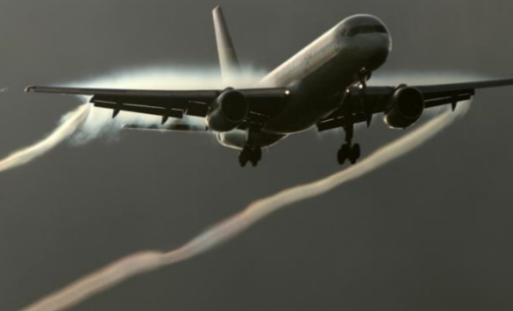

Figure 4- the picture is from Van Dyke’s Album of Fluid Motion depict low speed flow over a lifting wing of finite span.

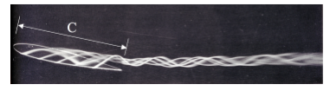

Figure 5- Vortex side view (Van Dyke’s Album of Fluid Motion)

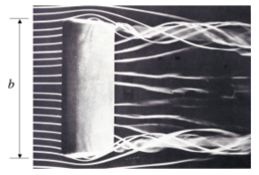

Figure 6- Vortex top view (Van Dyke’s Album of Fluid Motion)

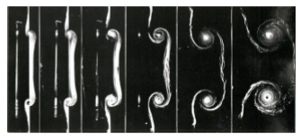

Figure 7- Vortices back view (Van Dyke’s Album of Fluid Motion)

These pictures fantastically illustrate the three-dimensional flow over the wing. In every case the wing has lift resulting in reduced pressure above the wing and exaggerated pressure below compared to the free stream pressure.

The upstream influence of the elevated pressure below the wing leads to a divergence of the smoke lines prior to the wing. If the smoke lines had been positioned to pass above the wing one would instead see a convergence driven by the low pressure on the suction surface. This vital impact can even be clearly seen within the smoke lines that leave the trailing edge of the wing and diverge outward to affix the vortex rollup from the wing tips.

Near the wing the bound circulation thanks to lift ends up in an up-wash prior to the wing and downwash behind the wing similar to the flow created by a two-dimensional lifting wing of infinite span.

A very vital impact is generated by the flow because of the vortex combination that contains the wake. The semi-infinite sheet of vorticity distributed within the wake produces a downward velocity element within the free-stream prior to the wing, at the wing and far downstream.

The downwash by the wake results in a discount within the angle-of-attack of the wing relative to the free stream, reducing the lift. additionally, the downwash rotates the oncoming flow vector at the wing resulting in a element of drag. And this can be the results, added in real finite wings aerodynamic characteristics. CFD simulations have shown this phenomenon and here the results of one simulation is according. These results are valid with National Aeronautics and Space Administration experimental works and is showing Pressure coefficient contours at vortex for various locations(x/c), computed at 10° angle of attack and free stream velocity of 170 ft/s.

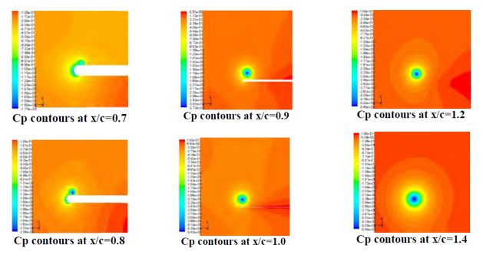

Figure 8- Cp contours at different location (looking upstream from back)

If an airfoil's vortex produces downwash, in different places the airframe should conjointly manufacture an identical quantity of upwash, in "stable flight" this happens more or less within the frame surface envelope; it can conjointly occur outside of the airframe envelope below special circumstances. The term upwash is used to visit regions around a craft or airfoil wherever the air is acquiring the alternative direction to downwash. The wingtip vortices induce an upwash outside the wingspan of a craft or airfoil equalization downwash created by upper wing surfaces Migratory birds build use of this upwash when they fly in an exceedingly V formation.

## References

[1]. Richard L. Kline & Floyd F. Fogleman. Dec 19, 1972. Kline Fogleman Airfoil for Aircraft. *United States Patent No: 3706430*.

[2]. Richard L. Kline & Floyd F. Fogleman. Sept 6, 1977. Airfoil for Aircraft having Improved Lift Generating Device. *United States Patent No: 4046338.*

[3]. FathiFinaish and Stephen Witherspoon. January 1998. Aerodynamic Performance of an Airfoil with Step-Induced Vortex for Lift Augmentation. *University of Missouri*.

[4]. Adam Joseph Wells. 2005. Experimental Investigation of an Airfoil with COFLOWJET Flow Control. *University of Florida*.

[5]. William S Johnson paper on “Investigation of the Kline-Fogleman Airfoil Section For Rotor Blade Applications”

[6]. Mohammed Ahmed Rasheed & Ahmed Adnan AL-Qaisy. 2008. Experimental Investigation of Aerodynamic Characteristics of NACA 23015 under different angles of attack and Comparison with Available Package. *Mechanical Engineering Department. University of Technology Baghdad*.

[7]. MILNE-THOMSON. L.M.,” TheoreticalAerodynamics”Emeritus Professor of Applied Mathematics, University of Arizona, Emeritus Professor of Applied Mathematics in the Naval College ,Professor of Applied Mathematics in Brown University, Emeritus Professor of Applied Mathematics Research Centre at the University of Wisconsin Visiting Professor at the Universities of Rome,Queensland,Calgary, Otago.

[8]. HANSEN. R. JAMES. D.BRYAN TAYLOR, JEREMY KINNEY, and J. LAWRENCE LEE, “The wind and Beyond”, National Aeronautical and Space Administration, Washington, D.C.

[9]. L.J CLANCY. Aerodynamics for students.

[10]. JOHN D. ANDERSON JR. Fundamentals of Aerodynamics.

[11]. Jacobs, Eastman N., Ward, Kenneth E., and Pinkerton, Robert M.: The Characteristics of 78 Related Airfoil Sections from Tests in the Variable~Density Wind Tunnel. NACA Rep. No. 460, 1933.

[12]. Jacobs, Eastman N., and Pinkerton, Robert M.: Tests in the Variable-Density Wind Tunnel of Related Airfoils Having the Maximum Camber Unusually Far Forward. NACA Rep. No. 537, 1935. _

[13]. Jacobs, Eastman N., Pinkerton, Robert M., and Greenberg, Harry: Tests of Related Forward-Camber Airfoils in the Variable-Density Wind Tunnel. NACA Rep. No. 610, 1937.

[14]. Stack, John, and Von Doenhoff, Albert E.: Tests of 16 Related Airfoils' at High Speeds. NACA Rep. No. 492, 1934.

[15]. Jacobs, Eastman N., and Sherman, Albert: Airfoil Section Characteristics as Affected by Variations of the Reynolds Number. NACA Rep. No. 586, 1937.

[16]. Pinkerton, Robert M., and Greenberg, Harry: Aerodynamic Characteristics of a Large Number of Airfoils Tested in the Variable-Density Wind Tunnel. NACA Rep. No. 628, 1938.

[17]. Jones, B. Melvill: Flight Experiments on the Boundary Layer. _ Jour. Aero. Sci., vol. 5, no. 3, Jan. 1938, pp. 81-94.

[18]. Jacobs, Eastman N., and Abbott, Ira H.: Airfoil Section Data Obtained in the N.A.C.A. Variable-Density Tunnel as Affected by Support Interference and Other Corrections. NACA Rep. No. 669, 1939.

[19]. Theodorsen, Theodore: Theory of Wing Sections of Arbitrary Shape. NACA Rep. No. 411, 1931.

[20]. Stack, John: Tests of Airfoils Designed to Delay the Compressibility Burble. NACA Rep. No. 763, 1943.

[21]. Jacobs, Eastman N.: Preliminary Report on Laminar-Flow Airfoils and Jirew Methods Adopted for Airfoil and Boundary-Layer Investigations. NACA ACR, June 1939.

[22]. Abbott, I.H., von Doenhoff, A.E., and Stivers, L.S., “Summary of Airfoil Data”. NACA Report no. 824, 1945

[23]. Timmer, W.A., “An overview of NACA 6-digit airfoil series characteristics with reference to airfoils for large wind turbine blades”. ,2009

[24]. Loftin, L. K., and Poteat, M. I., “Aerodynamic characteristics of several NACA airfoils sections at seven Reynolds from 0.7*10^6 to 9.0*10^6

[25]. Abbott, Ira H., von Doenhoff, Albert E., and Stivers, Louis S., Jr.: “Summary of Airfoil Data.” NACA ACR No. L5C05, 1945.

[26]. Module 08, Basic Aerodynamics, Part 66 courseware.

[27]. J. Anderson, “Fundamentals of Aerodynamics”.

# Literature Review

The chapter summarizes the most relevant concepts concerning wingtip effects in fixed wings, methods for vortex reduction and types of tip devices suggested and used. Basic discoveries that go back to 1960s are covered; however, the most emphasis is drawn to advancements over last two decades.

## Background

The history of winglets begins therewith of human flight, qualitative analysis back to the late 1800s. In fact, the primary studies on wingtip devices were conducted in 1897 by English engineer frederick W. Lanchester. He Associate in Nursingd fellow engineers of the time noted however powerfully the shape of an aircraft’s wing influenced multiple facets of its aerodynamic potency.

Lanchester’s theoretical studies and experimental investigations of this phenomenon indicated that putting a surface at the wingtip may powerfully cut back the wingtip drag underneath high-lift conditions. He designed and proprietary such surfaces, calling them “endplates.” However, at cruise conditions his style created giant flow separations, generating overlarge a rise in profile drag to justify its use.[2] his theory couldn't cut back the drag of craft despite reducing the induced drag. the rise within the viscous drag throughout cruise conditions outruns the reduction in induced drag [1].

Unfortunately, additional development would then be very slow for round the next seventy years. The Wright brothers placed what they known as “side curtains” or “blinkers” on a number of example models of their Wright Model B craft. This was, however, a airplane wherever the side curtains were placed between the wings for stability. the stability issue would become another key thought for winglets from this time on.

The next tiny progression within the history of winglets would are available in 1922 from Elliott Reid, engaging at Langley. He was learning the results of protecting control surface tips. His work showed that as compared to an unaltered airfoil, all changed tip forms were slightly inferior at tiny raise coefficients nonetheless provided for a substantial reduction of induced drag at high-lift coefficients [3].

Paul Hemke [4] would depend on this data in 1927, once he developed a number of the rudimentary formulas want to calculate the induced drag of endplates for mono- and biplanes. His calculations showed good agreement with experimental results which the shape and section of endplates were vital.

After world war II, a German technologist, Dr. Sighard Hoerner, came and work in the united states. Wright-Patterson Air Force Base in Ohio. whereas there, he completed development on his drooped wingtips in 1952; they're usually spoken as “Hoerner Tips” in classrooms nowadays. They were used on gliders for years; and although not excessively effective, they did direct the vortex far from the wing’s high and increase the wing’s overall lift-to-drag magnitude relation.[5] a small amount of further analysis was done by British aeronautical analysis Committee in 1956 to analyze “nonplanar” (no horizontal) lifting systems. Its members saw theoretical potential for aerodynamic enhancements at the wingtips, however experiments once more confirmed that current styles created an excessive amount of further profile drag to justify their use. [6]

The Organization of the petroleum exporting Countries (OPEC) oil embargo and ensuing energy crisis, starting in 1973, smartly revived interest in energy-saving techniques and analysis. In response, National Aeronautics and Space Administration created the craft Energy potency (ACEE) program. At the time, Richard T. Whitcomb was an American aeronautical engineer working for NASA’s Langley center, primarily with the 8-foot transonic Pressure Tunnel. His innovations had greatly contributed to the previous development of the supercritical surface with the new ACEE program, he switched focus to the wingtip-induced drag development.

With the new ACEE program, he switched focus to the wingtip-induced drag phenomenon. He was reportedly galvanized by an editorial in Science particularization the utilization of tip feathers by soaring birds to regulate flight characteristics. What set Whitcomb with the exception of the other scientists learning the bird’s tip feathers was his deeply intuitive and organized approach in emulating them for craft.

With the new ACEE program, he switched focus to the wingtip-induced drag phenomenon. He was reportedly galvanized by a piece in Science detailing the utilization of tip feathers by soaring birds to manage flight characteristics. What set Whitcomb with the exception of the other scientists learning the bird’s tip feathers was his deeply intuitive and arranged approach in emulating them for craft.Whitcomb began experimenting with wingtips in 1974. His analysis led him to suppose that a near vertical, winged surface at the wingtip might so cut back the strength of trailing vortices, if properly designed. He pictured that they'd extend on top of and, in sure cases, below every wingtip. a correct style would need a balance between can’t, the winglet’s angle off vertical, and toe, the angle the winglet deviates from airflow [2]. In Whitcomb’s own report, printed in 1976, he found that previous experimenters had primarily discovered the actual fact that winglets would produce larger moments on the wings, requiring heavier wing-support structures to accommodate. This was thought to render simple wingtip extensions simpler. Thus, the pursuit of winglets was minimal or forgotten apart from certainly sweptback and delta-wing configurations wherever the vertical surfaces did give larger directional stability. What his predecessors had unnoted, however, was that so as for winglets to be used with success, they have to manufacture significant side forces to decrease lift-induced flow on top of the wingtip and outflow below the tip. during this sense, they may be known as “vortex diffusers” [1]. One had to watch out that flow separation failed to occur at any essential speeds, either on the winglet surface or at the winglet-wing junction [8]. To do this, careful thought should be taken in their style, and strictly vertical surfaces aren't optimum for many flight conditions.

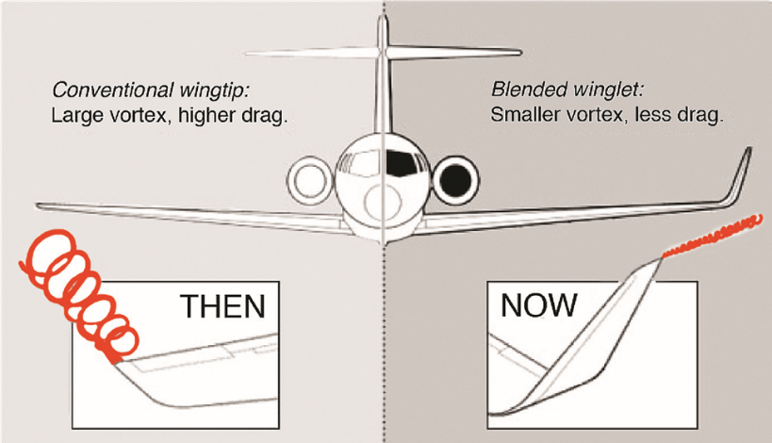

Figure 9- This example shows how large an impact winglet can make on the diffusion of vortices (Aviation Partners, Inc.).

If angulate properly, winglets might really produce a elevate force from the vortices and thrust once angulate forward [2]. nonetheless they maintained identical or lower bending moment and a smaller wingspread with larger flight stability than tip extensions in most cases. to worry the actual fact that the look of those surfaces needs respectable care and attention to airfoil aerodynamic characteristics, similar in effort and class to those needed for wing style, Whitcomb referred to as them “winglets.” [8]

Whitcomb’s style was specifically supposed for lifting and subsonic Mach numbers, with primary surfaces situated rearward higher than the tips and smaller secondary surfaces placed forward below the tips (figure 2). They were designed with first-generation, narrow-body aircraft jet transports in mind. His team’s construction tests at Langley showed an incredible reduction in induced drag of just about twenty percent and a rise in wing lift-drag (L/D) magnitude relation of roughly nine percent. This was doubly the performance sweetening given by simple tip extensions. [1]

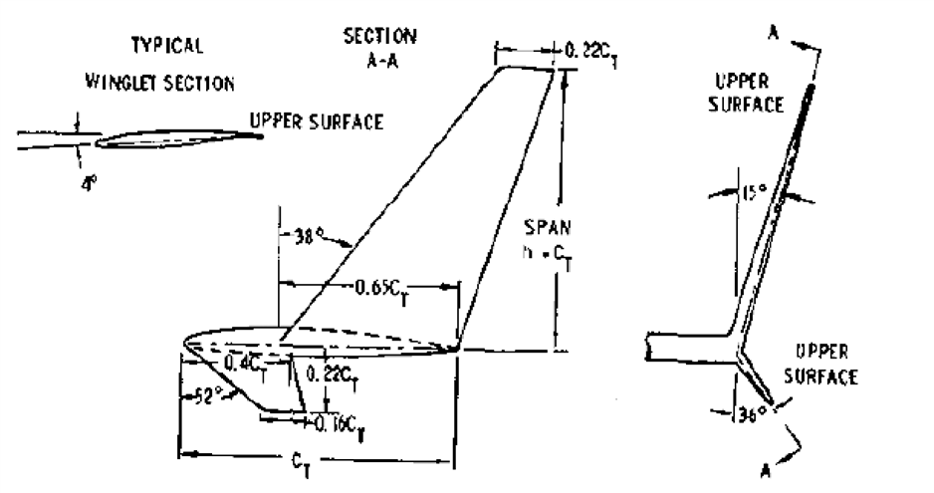

Figure 10- The original design for a set of winglets carefully designed by Whitcomb and his team at Langley (Richard Whitcomb, NASA Langley Research Center).

Before the complete findings of Whitcomb’s winglet work on National Aeronautics and Space Administration were developed and flight-tested, burt Rutan flew his famed home-built Vari-Eze. Rutan was Associate in Nursing american engineer UN agency specialised in light-weight, strong, and energy-efficient craft. His Vari-Eze was the primary plane to formally be designed, built, and flown victimisation NASA-inspired winglets. His maiden flight was in 1974. though he fastidiously designed the winglets on the Vari-Eze for potency, his primary focus was to use them for stability on a front fabrication to prove its viability as a secure and economical various to standard wing styles. The Vari-Eze set several flight-distance records of the time within the under-500-kilogram category. Rutan’s later voyager design was to be the primary craft to fly round the world without stopping or refueling in 1986, though its winglets got ripped off in flight. [8]

Ever since the winglet technology has been introduced, the benefits were being printed. Dr.Whitcomb has performed an experiment with the winglet within which the winglet shows reduction in induced drag two hundredth 200th. In 1977, Heyson created Associate in Nursing experiment to review the benefits of Whitcomb’s winglet. His results indicate that winglets would cut back the induced drag over tip extension and can be at its best once it's nearly vertical [16].

In 1978, consequent work analysis for low-speed general aviation craft found that coming up with for this category of craft was easier and stood to achieve well still. The wing taper was shown to be a crucial thought, and wing L/D might show enhancements of up to fifteen percent. [7] In early 1978, Langley conjointly organized a gathering with the aeroplane, business jet, and private aircraft industries. it absolutely was to concentrate on advanced technologies developed by National Aeronautics and Space Administration for conventional takeoff and landing (CTOL) craft. A primary goal of the convention was to formally share Langley’s discoveries concerning winglets. several of the key craft producers like Lockheed and therefore the Boeing Company acknowledged the increased potency NASA’s winglets had to supply. Upon completing their own studies, however, they determined that value of retrofitting their fleets with winglets wasn't definitely worth the cost of fabrication.

On the other hand, the business jet community was quickly fond of winglets. Learjet created the Model twenty-eight as a work for its new high-aspect-ratio wings, adding NASA’s winglets in 1977 (figure 3). The winglets improved directional stability and supplementary 6.5 % to the flight vary. The Model twenty-eight performed thus remarkably and was thus widespread at conventions that the model entered production in 1979. Winglets were enclosed on consequent Learjet models furthermore. Learjet competitors weren't so much behind either. Gulfstream enclosed winglets on their Gulfstream III, IV, and V models. The Gulfstream V even received the 1997 miner Trophy, set seventy other national and world flight records, and allowed for unprecedented nonstop New York-to-Tokyo business trips.

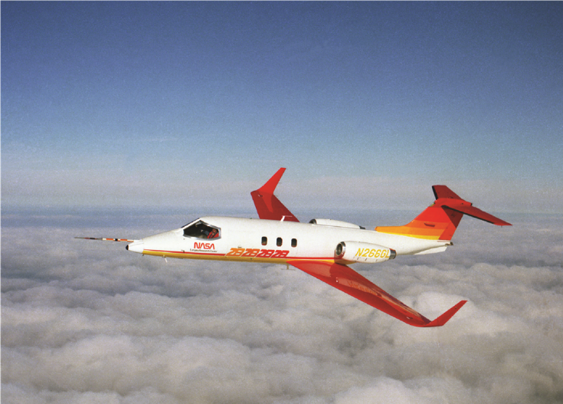

Figure 11 The Learjet Model 28 with its newly designed winglets (NASA Langley Research Center, UID: SPD-NIX-EL-1997-00215).

McDonnell Douglas was conjointly very impressed with NASA’s findings on winglets. the corporate instantly began research and development as an alternate to increased wingspan for their DC-10. [2] increased wingspan could be an essential issue for planes that are already thus large as to take up all accessible area at airport runways and loading bays. In their own flight-test on a modified DC-10, McDonnell Douglas researchers took elaborate information on flutter, buffet boundaries, stability and management characteristics, stall speed impacts, drag reduction, and ranging load and flight conditions. They ultimately determined that winglets considerably improved most of those flight characteristics, with associate degree overall 3-percent reduction in fuel burn and 5-percent reduction in takeoff distance at the utmost takeoff weight. [6] unfortunately, the high prices of the Federal Aviation Administration (FAA) recertification method created adding winglets to this DC-10 fleets unfavorable. however, all wasn't lost, and therefore the expertise gained was instead applied to the new, advanced, spinoff design known as the MD-11. this might expand Pacific air routes, because it might carry three hundred passengers over 8,200 miles and entered service in 1990. [2]

For NASA, full-scale flight evaluations would begin in 1979 at Dryden Flight centre in cooperative operation with the Air Force. Evaluations were to be conducted employing a Boeing KC-135 Stratotanker. it absolutely was chosen for two main reasons. First, the Air Force wished to explore the probabilities of retrofitting its aging fleet of tankers to create them a lot of economical. Second, the KC-135 exemplified ancient early jet transports that featured elliptical-type span loading and comparatively high loads on the outer wing panels. Flight evaluations confirmed science lab work and showed a 7-percent gain within the L/D quantitative relation and a 20-percent reduction in induced drag at cruise conditions. although this was an enormous success, it absolutely was instead set to retrofit the fleet with new, a lot of economical engines that were conjointly necessary at the time.

Back within the world of general aviation, the Boeing Company, that had at first been reluctant to feature NASA-developed winglets, finally set it absolutely was price effective to include them on it craft in 1985. The Boeing 747-400 was the primary giant U.S. commercial transport to do so. Winglets increased the vary of the 747-400 by over 3 % and helped to limit the wingspan, that already took up nearly all area at airfield loading bays. [9] withal, the Boeing Company did attempt to leave off the smaller winglet below the wingtip in accommodation of ground-handling instrumentation.

On the European front of craft manufacturers, airbus developed a variant of the Whitcomb winglets. airbus known as its wingtip solutions “wingtip fences.” The fence surfaces extended both on top of and below the wingtips, trying additional sort of a “V” at the end of the wing instead of the tip that shaped out of the wingtip naturally, as developed at independent agency. This style was developed by British aerodynamicists at Hatfield and Hertfordshire, U.K., and it had been additional suited to the airbus wing vogue. They were first installed in 1985 on the A310-300 with a savings of virtually five percent in fuel prices. [2] it's conjointly necessary to notice that in 1988, the Ilyushin Il-96 was the primary Russian jet to feature winglets. a lot of their analysis, however, isn't readily obtainable.

Jones and Lasinski (1980) [42] analyzed elliptical formed wing tips and planned that if the limitation on planform is outdated by the structural constraint on the integrated bending at the basis then per Prandtl lifting line theory. a tenth reduction in induced drag may be achieved by a tenth increase of wing span with larger taper ratio. They found that identical result may be reached by a 15 percent vertical extension at the wingtip. Conley (1980) [41] has studied the impact of toe-angle on the Learjet winglet and terminated that toe-out angle will facilitate to fine tune and improve the performance. he noted that a winglet ought to be placed aft of the main wing quarter chord, therefore it doesn't position the magnified velocities over the inner surface of the winglet on the high velocities over the forward region of the wing upper surface. America Air Force and Boeing put together conducted analysis to retrofit a Boeing KC-135A Stratotanker with removable winglets and compared wind tunnel results with actual flight knowledge. The wind tunnel results were verified, and enhancements in fuel mileage between 4.4 % and 7.2 % were incontestable (Barber et al., 1981).

Later in 1980, R.T Jones created a look in winglets to work out its impact over the induced drag victimization Trefftz-plane theory and conducted that the vertical length of the winglet ought to be conducted than the length of horizontal extension so as to possess its gain over tip extension [10].

Aviation Partners Boeing declared that their APB blended winglet has saved quite a pair of billion gallons of fuel in 2010. APB additionally value-added that the winglets might save five billion gallons of fuel by 2014 that conjointly represents the whole reduction in carbon emission. Indeed, APB blended winglet on B737 showed increased in vary of concerning 5-7% thanks to overall reduction in drag. just in case of spiroid tipped wing, API has created a flight take a look at on Gulfstream II in 1993 and that they achieved quite 100% of fuel potency throughout the cruise conditions. Raked wingtip could be a unique design for Boeing B777 family and it's improved the aircraft’s performance by reducing the take-off field length, improved fuel potency and good climb performance. Raked wing tip might offer 2 chronicles reduction in fuel burn that is remunerated by one.3 million of fuel is saving annually .9 million of carbon-di-oxide emission annually. Sharklets is that the recent invention from the airbus Company for their A320 family. They claimed that sharklets would scale back fuel dissipate to three.4% and this corresponds to 700 a lot of carbon emission per craft in a very year. airbus also side that A320 might lift off with a lot of weight because of the performance of sharklets. The analysis created with spiroid tipped wing indicates that it would disperse the vortex effects with in brief span of time and thus the time for take-off and landing between the aircrafts would be cut back [17].

As per Keisuke (1985) [39], winglets have improved performance for many reasons, and parasite drag is one amongst the foremost necessary reasons behind that improvement. Winglets are very slender compared to wing-tip extensions so that they would have less parasite drag. If the basis bending moment and therefore the parasite drag are unbroken constant, a planar wing will be designed which can be a lot of economical. Yates and Donaldson (1986) [40] at National Aeronautics and Space Administration experimented on numerous configurations of accessible wing tip devices as well as a Whitcomb winglet, feather, and sail. They found that the whole tested configuration will cut back the drag by 10-15% if they're designed as Associate in Nursing integral a part of the wing. From here the thought of blended winglet was first generated. Kuhlman et al. (1988) [38] from National Aeronautics and Space Administration conducted experiments on winglet and wing style of aspect ratios one.75 and 2.67 with a taper ratio of zero.2. The sweep angle was within the vary of forty-five to sixty deg. The length of winglet was mounted to fifteen of the wing semi-span. foretold pressure drag for the winglet was 15 percent as compared to the wing alone at M=0.8, CL=0.3. the whole decrease in coefficient was 12-tone system compared to the wing alone case. Bending moment constant at wing root increased by 5-7%. However, separate studies were created on totally different configurations of winglets by researchers and airplane producers counting on numerous patents.

In 1994 Aviation Partners Iraqi National Congress. (API) developed Associate in Nursing advance design of winglet known as blended winglet. Louis B. Gratzer from point of entry has the patent for blended winglet and intention of the winglet is to cut back the interference drag thanks to sharp edges as seen within the Whitcomb’s winglet [11]. Later, “wing grid” thought was developed by La Roche from Switzerland in 1996 and got the patent for his invention [13]. the most purpose of all the on top of inventions was to decrease the strength of wake vortex and to cut back induced drag.

Blended winglet was developed by Grazter from point of entry in 1994. The distinctive style design winglet isn't any sharp edge found at the wing/winglet intersection and followed by smooth curve. Aviation Partners Iraqi National Congress. (API) and Boeing Company created collaboration in 1999 for the planning of advance blended winglets in 1999. electro-acoustic transducer Stowell, executive vice chairman of APB mentioned concerning the interference drag, Associate in Nursing aerodynamic development caused because of intersection of lifting surfaces, thence the winglet style was developed to beat the interference drag shaped at the junction of wing and winglet. The winglets were retrofitted in Boeing business jets and additionally in B737. currently these flights have their services in american airlines (Southwest airlines) and additionally in European airlines (Ryanair).

Gratzer has developed the spiroid-tipped wing technology and got the patent in 1992. One end of the spiroid tip is connected with forward a part of the wing tip and continues to make a spiral loop that ends at the aft portion of the wing tip. thus, it's oval formed when viewed from front. Spiroid tipped wing was created to cut back the induced drag and additionally to cut back the noise effects related to the tip vortices [12]. API has created their flight take a look at in Dassault Falcon 50 with spiroid tipped wing.

Dengbin et al. (1994) [44] investigated 3 different wingtip devices namely- wingtip sail, winglet and sheared wing tip. They found that everyone the tested tip shapes performed well and reduced induced drag at close to design condition Compared to `Wing tip extension’ of a similar length however the wing tip sail is best

Kravchenco (1996) [45] advised that modifications within the wingtip will either move the wake vortices away regarding craft longitudinal axis or scale back its intensity. Further, he analyzed and terminated that winglets have a better aerodynamic advantage solely up to philosopher 1.0, and it should produce structural issues thanks to hyperbolic bending moment at the foundation. Another study by Bagwill et al. (1994) exploitation VLM (vortex lattice method) model investigated winglets for RPV'S (Remotely piloted vehicles) and terminated that winglets increase potency for all cases, although the comparison was created solely on the wing while not winglet for inviscid cases.

Wing grid pure mathematics is outlined by 2 or additional wing like surfaces running parallel to every different from the tip of wing section that forms the grid. La Roche from switzerland command the patent for this invention since Oct, 1998. rather than entire wing with no tip devices, wing grid at partial span may be replaced. La Roche claimed that wing grid may give a lot of reduction in induced drag compared to wing span extension [13].

Raked wing tip from Boeing Company was designed by Herrick and got the patent in 2000 [14]. The raked tip is connected with the most wingtip with higher angle of sweep than the most wing. Boeing 777 long-range jets are designed with raked wingtip. additionally In 2006 the Boeing 777-200LR followed that trend.

In 2001 Smith et al. [33] have investigated multiple winglets mimicking the wingtip feathers throughout soaring and located them to assist within the diffusion of the wingtip vortices. but such improvement relies principally on reducing drag thanks to elevate and increasing L/D with very little respect to the physical structures that will be necessary to support such a style. Bourdin (2002) in his numerical study found that with fastened span up wash, a winglet produces larger lift-induced drag than downwash.

Boeing offered a retrofit winglet to its Boeing 737 classic and next-generation aircrafts in 2003, scaling down fuel value by four to six percent. The winglet itself was referred to as a blended winglet that allowed an additional reduction in drag and fewer aerodynamical interference thanks to a blended transition between the junction of wing and winglet [18]. Mattos.et al, [48] in 2003 showed that the winglets may increase associate degree aircraft vary by the maximum amount as seven percent at cruise speeds. a replacement winglet configuration was designed for the legacy Business Jet, that cruises at ratio of 0.80 and better elevate constant. Finally, the Embraer 170/175 and the larger 195 were designed with winglets. each sonic wind tunnel testing at DNW within the Kingdom of The Netherlands and at TsAGI facilities in Russia showed significant drag reductions provided by some winglet’s configurations underneath investigation.

Ever since Whitcomb revealed his results there has been done heaps of analysis on wingtip devices. Mark D. Maughmer (2003) has created himself illustrious within the aviation world for his contribution to winglets on sailplanes [43]. during a attempt to error process he designed the PSU-90-125 device, specially created for sailplane winglets. the concept of winglets for sailplanes was by no means new, but Maughmer was the primary one who might with success offer a winglet style that each increased the glide ratio and unbroken the parasite drags at a minimum level.

Pfeiffer (2004) [32] developed a way to optimize each induced and profile drag, whereas the analysis centered solely on winglet orientation and not on size. Results showed solely tiny variations within the root and tip incidences between an induced-drag-only solution and one with profile drag enclosed at high subsonic speeds. B.B. Prananta, A. namer in 2005 [49], investigated to realize understanding of the aeroelastic behaviour of Associate in Nursing integrated versatile wing and winglet combination, and to verify and validate ways for the prediction of wing deformations. three different configurations are investigated: the quality winglet, an outsized winglet, and also the clean wing for reference. Verification of ways for the prediction of the particular flight form of the wing at numerous cruise conditions is performed by comparison with optical measurements of the in-flight deformations. it's concluded that current aeroelastic prediction ways, supported Navier-Stokes flow modelling, offer an acceptable analysis tool for baseline and trade-off studies of versatile craft. The AWIATOR (Aircraft wing with advance technology) team contributed CFD and comparison it with real flight take a look at. the strategy of them in real take a look at was place some detector at length of half span with these intervals, 32.5% , 50% , 67% , 81% , 93% , 99% . Tested in Mach number from 0.8 to 0.84 at 35000 feet with suppose fuel in wing are constant there for neglect inertia force. Prithvi dominion Arora et al .(2005) [51], studies the aerodynamic characteristics for the craft model with NACA (National consultative Committee for Aeronautics) wing No. 65-3-218 by victimization subsonic structure of one thousand 1000 * 1000 mm rectangular take a look at section and 2500 millimeter long of aeromechanics Laboratory faculty of Engineering (Universiti Putra Malaysia). Six elements wind tunnel balance is employed for activity carry, drag and pitching moment. Tests are conducted on the craft model with and while not winglet of two configurations at painter numbers 1.7 * 105, 2.1*105, and 2.5 *105. carry curve slope will increase a lot of with the addition of the elliptical winglet and at constant time the drag decreases a lot of for the craft model with elliptical formed winglet giving a position over the craft model while not winglet as so much as Lift/Drag ratio for the elliptical winglet is taken into account. The results that set out from testing and activity of wing tunnel will discussion in two sides. initial carry state of affairs and also the second facet goes to the coefficient. The results begin from testing indicate scale back induce drag and increase L/D by 15-30 zip. If increasing the angle of attack we have a tendency to see carry constant increase till most value of C(L ).It is not therefore neoteric result as a result of we all know it before however if we have a tendency to see the result with ellipse winglet there's a distinction. the value of C(L ) in high Reynold range increased roughly ten percent from model while not winglet.

Bourdin et al. (2006) investigated the winglets with variable cant angles as a full of life control surface. They found that though one or each winglet are adjusted, it affects the multiple moment axes, therefore providing some of management mechanisms. Takenaka et al. (2008) utilised CFD to analyze the structural stresses related to winglets and located that if the winglet isn't integrated into the most wing, there'll be wave drag at the junction. They investigated an advert aviation plane at Mach 0.8, at a Reynolds range of about 1.2 × 106. Their objective was to optimize the performance supported minimum fuel and Gross Takeoff Weight (GTOW), that are full of the winglet performance. Their improvement resulted within the style method of integrated winglet design with a leading edge aft of the main wing vanguard, and it's been noted that the dominant parameters for the drag reduction are the span length and also the cant angle of the winglet.

Alexander et al. (2006) studied the wing tip devices at low and high speed victimisation lift and drag part analysis methodology. They found as per RANS computation sensible accuracy at high speed and lift. Mann (2008) [31] at airbus unreal a replacement wing tip that features a downwash tip with 180 deg. can’t angle and might endure aeroelastic deformation throughout flight. Takenaka et al. (2008) [34] whereas operating for style of winglet for commercial craft used multidisciplinary approach by fixing the fuel and take-off distance because the design constraint. CFD with mid-field drag decomposition shows that varied winglet defining parameters contribute to the wave, induced and profile drag. Ceron-Munoz et al. (2008) [21] experimented three varieties of processes, active, passive and reconciling to see the behavior of three different wingtip devices: delta tip, winglet, and also the Hoerner tip. The vortex generation was from three slots on the wing tip. the thought behind this was to review the potential use of reconciling multi-winglets for the reduction of induced drag victimisation different cant angles. They terminated that the Delta tip is extremely promising in agricultural craft with potential edges in combining each the three vectored Coanda jets and winglet configurations.

In 2009, airbus bestowed its own homogenised winglet style, the Sharklet, that provides a 3.5% decrease in fuel burn and a rise of up to 100nm in vary in keeping with the manufacturer; sharklets have performed up to expectations and are currently commonplace on the new A320neo family.

Cosin et al. (2010) [24] through a half model of wing-body investigation at Re=4*105 tested six totally different multi winglets. The device showed a thirty second increase in Oswald potency issue, leading to a seven-membered increase in aerodynamic potency. A 12-tone system increase within the most rate of climb and seven increase in most vary was additionally obtained. Hicken Associate in Nursingd Zingg (2010) [26] reduced the induced drag of varied non-planar configurations supported mathematician equations victimisation an improvement formula. They found that elliptical planform isn't optimum once side-edge separation is gift. Winglet and box-wing when optimized were found to possess span efficiencies that agree with lifting line analysis once the whole pure mathematics is accounted for linear analysis. For this reason, (span wise and vertical bound) nonplanar split-tip pure mathematics outperforms each the winglet and box-wing as a result of it will simply maximize the vertical extent at the tip. Inam et al. (2010) [30] experimented with three different wingtip devices specifically rectangular, triangular and circular by variable reynolds range from 0.16-0.25 * 106. They found that drag reduction was within the vary of 26.4% to 30.9%. They additionally terminated that triangular wingtip style is splendid than the other two. Weierman and Jacob (2010) [36] studied optimisation of winglet to be used in UAV’s compared the assorted parameters of each Whitcomb and blended winglet with VLM methodology at low reynolds numbers. They found than CL/CD will increase for larger radius however the basis bending moment is constant and is just influenced by the angle of attack. Also, the simplest results for CL/CD are achieved for the lower cant angles. However, since the length is outlined to keep up a continuing height of one meter, the lower the cant angle, the longer the winglet can need to be to succeed in the mandatory height.

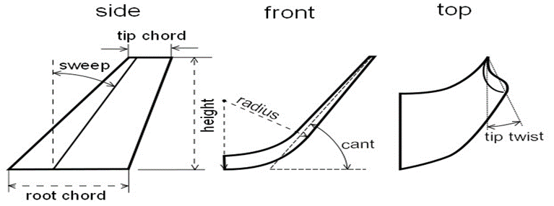

Figure 12 Angles related to wing which affect the aerodynamics function of airplane: Sweep, can’t and twist angle (Weierman & Jacob, 2010)

CL/CD| max happens at the utmost radius and also the minimum cant angle. The minimum root bending moment, however, lies at the cant angle bigger than seventy deg. The vary and endurance severally for a blended winglet is 15.61% and 33.96% more than a Whitcomb winglet. CD0 |VLM (Computed through Vortex lattice method) predicts a rise within the vary of 10.75%for the Whitcomb winglet style and a 28.03% increase within the vary for the blended winglet design. The VLM model predicts that the Whitcomb winglet will increase endurance by 28.17% and also the blended winglet will increase it by 71.7%. mistreatment CD0 |WT (Estimated through Wind tunnel), the vary is exaggerated by 14.49% mistreatment the Whitcomb winglet and 31.85% mistreatment the optimized blended winglet. thus, each experiment and simulation agree on these parameters. christopher and Jeffrey (2011) [25] developed a technique to alter the angle of wing tip by connecting the specified signal to wing tip rotating mechanism; this is often to create the angle of the main wing and wing tip different.

Chang and Hwan (2012) [23] investigated half wing model with ratio 3.2 utilizing three different wingtip configurations specifically, square-cut, straightforward fairing and Whitcomb's. These were visualised at numerous angles of attack. They found that vortices at a distinct angle of attack had distinct formation and characteristics. Whitcomb wing tips vortices were found to possess additional reduction in strength. Another investigation on a half-body model of a trainer craft with wing tip processing, mounted and accommodative multi-winglets was distributed by Ceron-Munoz et al., (2013) [22], they conjointly found that each one of them reduce the induced drag, however the utmost reduction occurred with multi-winglets. Giuni and inexperienced (2013) tested the round and square wing tip on a NACA 0012 wing mistreatment smoke visualisation. They found two different reasons for the vortex fluctuation close to wake. One is that the rolling-up of vorticity Associate in Nursingd second is a merger of secondary vortices with primary vortices. an in-depth study was performed by Margaris, Marles and Gursul (2010) to look at the impact of continuous processing from high ratio jet on the tip vortex within the close to wake and located that this jet produces a try of counter-rotating vortices of unequal strength, their interaction with the tip vortex results in single or multiple-vortex wakes.

Crawford (2014) [46], a rise in wing potency by ripping the wing tip like birds’ feather wingtip is feasible and located that the most effective performance is achieved through spreading the wing tip just like the spreading of feathers over an oversized angle of the wing planform.

Rademacher (2014) [29] studied the winglet to retrofit a Dassault Falcon-10 small size business jet employing a vortex lattice methodology solver. He investigated primarily the impact of can’t angle, sweep angle and taper magnitude relation and located winglet span and can’t angle supply highest gains concerning performance however taper magnitude relation and sweep magnitude relation give a very little contribution. Rectangular wing NACA0012 with slotted wingtips has been analyzed for low Reynolds variety mistreatment Fluent. The simulation was done with and without winglet with a decrease in induced drag largely at an angle of attack of 8°. Such form of wing is specially employed in UAV and MAV applications. Jin and Yee (2014) [27] designed a wingtip that they referred to as broken wingtip. Their main purpose was to scale back the vortex generation behind the wing. Numerical simulation mistreatment incompressible Navier-Stokes equation was used to see the impact of that wing shape. They found that vortices were additional dissipative than the most wingtip and ensuing vortices will scale back the strength of primary vortex at way field.

Ceron-Muñoz et.al. in 2015[46], presents a computational analysis of the behavior of various devices coupled on a non-conventional configuration model referred to as the blended Wing Body (BWB). two wingtip devices (winglet and C-wing) and two wing devices (fence and gurney flap) were analyzed so as to acknowledge each their properties and their interference on the pattern of the fluid over the model. The results show that adding devices to the BWB may improve the craft performance still because the aerodynamic potency, decreasing the drag coefficient at higher angles of attack.

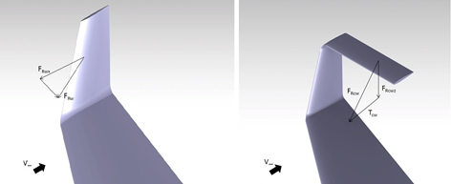

Figure 13 Winglet (a) and C-winglet (b) )**[46]**

Rameshkumar et.al in 2016 [50], designed and simulated a model of winglet for craft. by exploitation computer code like CATIA -V5 and ANSYS a model of winglet device is intended and additionally tasted. Hesham S. M. Helal et al. 2016 [52] analytical study includes NACA653218airfoil section coordinates for the wing design and also the winglet with the intermingled style. the numerical validation procedure by FLUENT ®6.3.26, computational fluid dynamics computer code with The Spalart-Allmaras turbulence model is delineated for determination and estimation aerodynamic characteristics for three-dimensional subsonic rectangular wing (with NACA65-218airfoil section). The study complete blended winglet with different angles at (30, 45, 60, and 90) on the wing. The wing is drawn exploitation Gambit 2.4.6 with a chord length of 1.755 m. The NACA 65-218 device is extruding by 14.7 m with wing taper magnitude relation adequate to 0.4. The winglets are created with constant device at the tip wing with taper magnitude relation equal to 0.5. The winglet length is regarding 17 November of the semi-span of the wing. The affiliation between the wing and also the winglet may be a curved edge. From CFD models run at a ratio of 0.2 at sea level,the pressure and temperature of air at this height are 101325 pa and 288.2 K, respectively, and also the results show that the wing with winglet will increase lift to drag (L/D) magnitude relation by just about 6 June 1944 to15% over wing without winglet. It depends on angle of attack on the various phases of flight, and show the foremost economical angle of attack happens at four degrees.

**Guerrero et.al** in **2018**,**[47]** By using computational fluid dynamics, studied the influence of the winglet can’t angle and sweep angle in the performance of a benchmark wing at a Mach number of 0.8395. The results demonstrated that by carefully adjusting the cant angle, the aerodynamic performance can be improved at different angles of attack.

**Nicholai Olson in 2018** **[53]**, present a frame work for tuning and validating ﬂight loads for a Cessna Model 525B business jet equipped with Tamarack® Aerospace Group’s active winglet modiﬁcation, ATLAS® (Active Technology Load Alleviation System). ATLAS® by reducing loads allows aerodynamic improvements to be realized. By using the calibrated strain-gages flight load will be measured and also thy are used to tune and validate a Nastran doublet-lattice ﬂight loads model. Methods used to tune the model include uncertainty quantiﬁcation of the Nastran model form and calculating the uncertainty of the model for any given ﬂight condition within the operating envelope of the airplane.

A summary of the steps used to tune, validate, and verify the loads is provided below**:**

**1)** Extract ﬂight test data. TACS sweep, wind-up turn, and side slip maneuver data were taken to tune and validate loads on the wing and winglet. These data were used throughout the process of tuning and validation.

**2)** Tune Nastran model to ﬂight test data. Nastran was tuned using DMI commands to closely match ﬂight test loads. Nastran cases were run through the load’s solver at ﬂight conditions matching the ﬂight test points and the model was tuned to ﬂight test spanwise bending moment distributions due to aerodynamic forces.

**3)** Assess uncertainties and predictive capability of model. The prediction intervals of model form uncertainty were computed and techniques are provided for assessing the model accuracy throughout the ﬂight envelope.

**4)** Validate using remaining ﬂight test cases. Validation of the tuned Nastran loads model was performed by comparing loads out puts of the ﬁnal tuned model at matching ﬂight conditions to ﬂight test points. The method uses a variety of corrections to tune the predictive loads model, in this case Nastran SOL144 doublet lattice method, to improve the accuracy of the solution.

**V.Madhan Raj in 2019 [54]** worked on a new idea of foldable winglets. Till now the winglets are fixed in an aircraft upwards but the previous idea examined the idea to fold the winglets to any angle at different angle of attack. The results were based on a series of test done a different angle of attack from -15 degrees to +15 degrees. The tests were performed at constant pilot velocity without varying the rpm of the engine in order to only investigate the aerodynamic effects of foldable wingtips.

**Marcle Ilie** **in** **2019 [55]** worked on winglets effects by **Large Eddy Simulation** approach to compare two cases of single and double-winglets. The investigation is performed for Re = 1.3e6 and reveals that the single-winglet design has a better aerodynamic performance compared with the no-winglet design. Further the double-winglet design causes a large pressure difference and thus, large lift. The double-winglet design reduces the tip vortex formation and thus, increase the aerodynamic performance. The brief results of their work are shown in figures1 to 4.

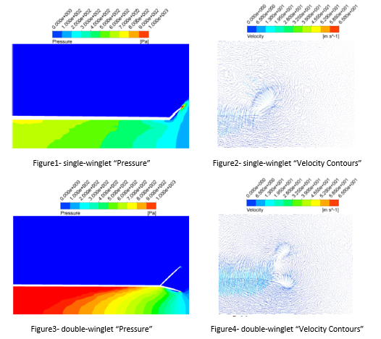

Figure 14- Winglet flow simulation

## References

1. R. T. Whitcomb, "A Design Approach and Selected Wing-Tunnel Result at High Subsonic Speed for Wing-Tip Mounted Winglets," NASA TN D-8260, 1976.
2. Richard Hallion, NASA’s Contributions to Aeronautics: Aerodynamics, Structures, Propulsion, and Controls, vol. 1 (Washington, DC: NASA SP-2010-570-Vol 1, 2010).
3. Elliott G. Reid, The Effects of Shielding the Tips of Airfoils (Rep. No. 201, Langley Memorial Aeronautical Laboratory, 1922)
4. Paul E. Hemke, Drag of Wings with End Plates (Rep. No. 267, Langley Memorial Aeronautical Laboratory, 1927),
5. Sighard Hoerner, Aerodynamic Shape of Wing Tips (Technical Report [TR] 5752, 1952), p. ii.
6. J.R. Agar and the staff of Douglas Aircraft Company, DC-10 Winglet Flight Evaluation (Washington, DC: NASA CR-3704, 1983), p. v
7. . J.F. Marchman III, H.F. Faery, Jr., and D. Manor, “Whitcomb Winglet Applications to General Aviation Aircraft” (Proceedings of AIAA Aircraft Systems and Technology Conference, 78-1478, Los Angeles, CA, 1978)
8. Joseph R. Chambers, Concept to Reality: Contributions of the NASA Langley Research Center to U.S. Civil Aircraft of the 1990s (Washington, DC: NASA SP-2003-4529, 2003),
9. Maurice Allward, “Wingtip Technology,” Putnam Aeronautical Review no. 1 (May 1989): 41.
10. R. T. Jones and T. A. Lasinski, "Effect of Winglets on the Induced Drag of Ideal Wing Shapes," NASA TM-81230, 1980.
11. L. B. Gratzer, "Blended winglet," ed: Google Patents, 1994.
12. L. B. Gratzer, "Spiroid-tipped wing," ed: Google Patents, 1992.
13. U. La Roche, "Wing with a wing grid as the end section," ed: Google Patents, 1998.
14. L. L. Herrick, et al., "Blunt-leading-edge raked wingtips," ed: Google Patents, 2000.
15. D. P. Raymer, et al., Aircraft design: a conceptual approach: American Institute of Aeronautics and Astronautics, 1999.
16. H. H. Heyson, et al., "Theoretical Parametric Study of the Relative Advantages of Winglets and Wing-tip Extension," NASA Langely Research Centre, Virginia1977.
17. J. E. Guerrero, et al., "Biomimetic spiroid winglets for lift and drag control," Comptes Rendus Mécanique, vol. 340, pp. 67-80, 2012.
18. Louis B. Gratzer,Blended winglet,US patent, (1994)
19. Mark D. Maughmer, Timonthy S. Swan, Steven M. Willits The design and testing of a winglet airfoil for low-speed aircraft ,19th applied aerodynamics conferences, CA, June 11-14,(2001),,AAIA Paper 2001-2478
20. Anderson, J. D. The fundamental of aerodynamics. New York, NY: McGraw Hill.,2001
21. Cerón-muñoz, H. D., Catalano, F. M. & Coimbra, R. F. (2008). Passive, active and adaptive systems for wing vortex drag reduction. Proceedings of the 11th Brazilian Congress of Thermal Sciences and Engineering society of mechanical sciences and engineering (ICAS 2008),2008.
22. Ceron-Munoz, H.D., Cosin, R., Coimbra, R.F.F., Correa, L.G.N., & Catalano, F.M. Experimental investigation of wing-tip devices on the reduction of induced drag. Journal of Aircraft, 2013, 50, 2-441
23. Chang, J., & Hwan, S , Visualization and PIV study of wing-tip vortices for three different tip configurations. Aerospace Science and Technology,2012, 16(1), 40-46.
24. Cosin, R., Catalano, F. M., Correa L.G.N., & Entz, R.M.U. (2010). Aerodynamic analysis of multi-winglets for low-speed aircraft. In proceedings of 27th International Congress of the Aeronautical Sciences (ICAS 2010).
25. Cristopher, A.K., & Jeffrey, P.S. ,United states patent, US 8083185 B2, 2011.
26. Hicken, J. E., & Zingg, D. W., Induced-drag minimization of nonplanar geometries based on the Euler equations. AIAA Journal, 48(11), 2564-2575,2010.
27. Jin, J.H. S., & Yee, K.,Numerical simulation of trailed vortex alleviation through chipped wingtip shapes. Journal of Mechanical Science and Technology, 28(9), 3605-3615. 2014.
28. Lilienthal, O. (2001). Bird Flight as the Basis of Aviation. Longmans green and company, New York.
29. Rademacher, P. R, Winglet Performance Evaluation through the Vortex Lattice Method. Dissertations and Theses Paper 178. Embry-Riddle Aeronautical University, Daytona Beach, Florida, 2014.
30. Inam, M.I., Mashud, M., Nahian, A., & Selim, S.M.S. Induced drag reduction for modern aircraft without increasing the span of the wing by using winglet. International journal of mechanical and mechatronics, 10, 49-53.,2010.
31. Mann, A. (2008). Wing tip devices. United states patent, 8342456 B2.
32. Pfeiffer, N. (2004). Numerical Winglet Optimization. 42nd AIAA Aerospace Sciences Meeting and Exhibit, Aerospace Sciences Meetings, AIAA 2004-0213.
33. Smith, M. J., Komerath, N., Ames, R., & Wong, O. (2001). Performance Analysis of a Wing with Multiple Winglets. *AIAA 19th applied aerodynamics conference, Anaheim, AIAA-*2407.
34. Takenaka, K., & Hatanaka, K. (2008). Multi-disciplinary Design Exploration for a Winglet. Journal of Aircraft, 45, 1601-1611.
35. Gratzer, L. B. (1992). Spiroid-tipped wing. United states patent, 5102068.
36. Weierman, J., & Jacob, J. (2010). Winglet design and optimization for UAVs. 28th AIAA Applied Aerodynamics Conference, AIAA-4224.
37. Gratzer, L. B. (1994). Blended winglet. United states patent, 5348253.
38. Kuhlman, J. M., Liaw, P., & Cerney, M. J. (1988). Theoretical/Numerical Study of Feasibility of Use of Winglets on Low Aspect Ratio Wings at Subsonic and Transonic Mach Numbers to Reduce Drag. NASA CR4174.
39. Keisuke, A. (1985). Theoretical Considerations in the Aerodynamic Effectiveness of Winglets. Journal of Aircraft, 22, 635-637.
40. Yates, J. E., & Donaldson, C.P. (1986). A fundamental study of drag and an assessment of conventional drag drag-due-to-lift reduction devices. Contractor NASA 18065.
41. Conley, N. (1980). Winglet toe-out optimization for the Gates Learjet Longhorn wing. Journal of Aircraft, 17, 851-855.
42. Jones, R. T., & Lasinski, T. A. (1980). Effect of Winglets on the Induced Drag of Ideal Wing Shapes. NASA TM-81230.
43. M.D. Maughmer. 2003. The Design of Winglets for High-Performance Sailplanes. Journal of Aircraft Vol. 40(6) pp. 1099–1106.
44. Dengbin, T., Qian, J, & Mingquan, S. (1994). Applications and developments of Wing-tip devices to Reduce Drag. *Journal of Nanjing University of Aeronautics and Astronautics, 1994-01*.
45. Kravchenco, S. A. (1996). The application of the wingtip lifting surfaces for practical aerodynamic. ICAS, 1338-1349.
46. H. D. Ceron-Muñoz , D. O. Diaz-Izquierdo, J. Solarte-Pineda∗, F. M. Catalano, AERODYNAMIC INTERFERENCE OF WINGTIP AND WING DEVICESON BWB MODEL, Aerodynamic Laboratory, São Carlos Engineering School-University of São Paulo-Brazil, September,2015
47. Joel Guerrero , Marco Sanguineti and Kevin Wittkowski, CFD Study of the Impact of Variable Cant Angle Winglets on Total Drag Reduction, 3 December ,2018 .
48. Bento S. de Mattos, Antonini P. Macedo, Durval H. da Silva Filho, Considerations about Winglet Design, 21st Applied Aerodynamics Conference, AIAA 2003-3502.
49. B.B. Prananta, A. Namer*, J.E.J. Maseland, J. van Muijden and S.P. Spekreijse, Winglets on large civil aircraft: impact on wing deformation, NLR-TP-2005-366
50. Khamis Ali Al Sidairi and G. R. Rameshkumar, Design of Winglet Device for Aircraft, INTERNATIONAL JOURNAL OF MULTIDISCIPLINARY SCIENCES AND ENGINEERING, VOL. 7, NO. 1, JANUARY 2016.
51. Prithvi Raj Arora, A. Hossain1, Prasetyo Edi, A.A. Jaafar1, Thamir S. Younis and M. Saleem, DRAG REDUCTION IN AIRCRAFT MODEL USING ELLIPTICAL WINGLET,2005
52. Hesham S. M. Helal, Essam E. Khalil , Osama E. Abdellatif,Gamal M.Elhariry, Aerodynamic Analyses of Aircraft-Blended Winglet Performance, IOSR Journal of Mechanical and Civil Engineering, May- Jun. 2016.
53. Nicholai Olson , Validation and Veriﬁcation of Flight Test Data on an Aircraft Equipped with Active Winglets, AIAA/ASCE/AHS/ASC Structures, Structural Dynamics, and Materials Conference, 8–12 January 2018.
54. V. Madhan Raj, Dilip A. Shah & P. Boomadevi, Preliminary investigation on the effects of folding wingtips on the aerodynamics characteristics of flexible aircraft, International Journal of Ambient Energy, Jun 2019.
55. Marcel Ilie1, Matthew White2, Valentin Soloiu3 and Mosfequr Rahman4, The effect of winglets on the aircraft wing aerodynamics; numerical studies using LES , AIAA Scitech 2019 , 7-11 January 2019.

# Methods Candidate to Use

## Surface Pressure Distributions

The pressure distributions of both upper and lower surfaces along the chord length of four segments (Segment- A, B, C and D) of four experimental wing models at selectedangle of attack (AOA). From the static pressure data, the respective coefficient of pressure (Cp) is calculated using equations which is discussed in this part.

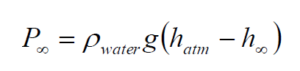The wind tunnel has a reference pressure tap located upstream of the test section and the pressure there is calculated from equation below

Values of Cp at any point over the airfoil surface can be approximated from the corresponding boundary values by using the first order Lagrange interpolation and extrapolation:

the results will be shown in a figure which horizontal axis represents the percentage of the chord length (%C) and vertical axis represents the surface pressure coefficient (Cp). The vertical axis above the zero line (horizontal axis) denotes the negative pressure coefficients or suction pressure coefficients and the vertical axis below the zero line denotes the positive pressure coefficients. The pressure coefficients of a wing without winglet are also measured and plotted. Then surface pressure distribution of all the wing planforms is discussed and compared.

## Lift Characteristics

The data taken from the pressure distribution are accustomed calculate traditional and axial forces on the wing models from balance. These traditional is employed to work out constant of elevate (CL), Then the impact of angle of attack on CL is studied and employed in comparison.

The lift will increase with increase in angle of attack to a maximum value. maximum this most value of angle of attack, elevate decreases drastically thanks to flow separation over the device surface. The elevate coefficients of the wing models underneath check for various angle of attack (AOA). this half is illustrated the comparison of the values of elevate constant for wings and additionally the stall angle of attack among rise.

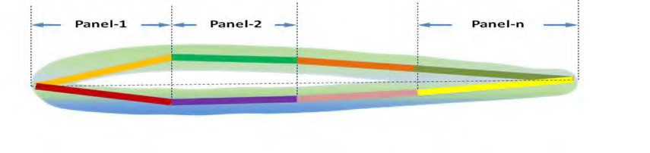

Figure 15- Paneling of the Wing Surface

both the surfaces of the wing section can be divided into small panels corresponding to a total of gaps between each pressure tap location When n is a number of panels, the equations can be converted to:

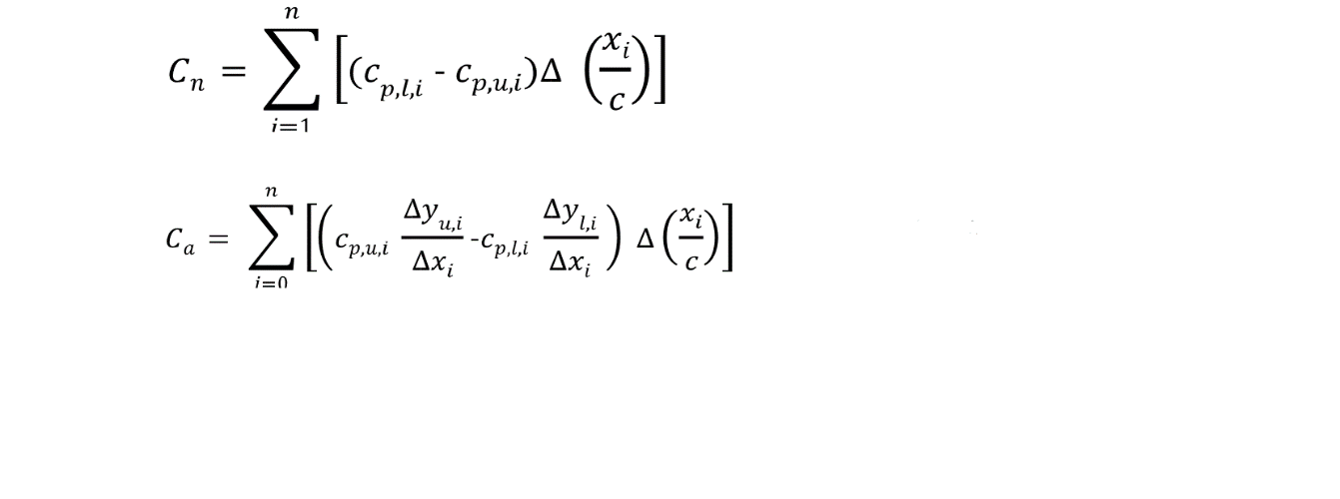

The interpolated and extrapolated pressure coefficients would be applied to Equation in order to get the normal and axial force at a section of interest. Lift and drag coefficient can be obtained from:

## Drag Characteristics

The data taken from the pressure distribution are used to calculate normal and axial forces on the wing models. These axials are used to determine coefficient of drag (CD). Then the effect of angle of attack on CD is studied and used in comparison. The drag coefficients of the wing models under test for different angle of attack (AOA). this part is illustrated the comparison of the values of drag coefficient for wings and also the critical angle of attack within drag coefficient rise.

Besides considering all equation in the lift part, the drag coefficient is calculated from equation below:

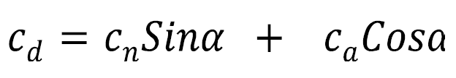

## Lift to Drag Ratio

The data taken from the pressure distribution are used to calculate normal and axial forces on the wing models. These normal and axial forces are used to determine coefficient of lift (CL), coefficient of drag (CD) and lift to drag ratio (L/D) of individual wing. Then the effect of angle of attack on CL, CD and L/D is studied and used in comparison.

The values of lift to drag ratio are plotted for various angle of attack. From this graph it is observed that the lift to drag ratio for wing with two wing models and. It is also evident that the wing without winglet has the lowest lift to drag ratio compared to wing with winglet models. And also, it can be found that the pattern of the lift to drag ratio is similar trend with National Airfoil Data selected NACA or not.

## Induced Drag

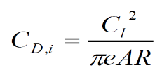Induced drag coefficients CD,i of all wing models are calculated from the value of CL at respective angle of attack from equation below:

The induced drag coefficients of the wing models under test for different angle of attack (AOA). It must be observed that the induced drag for wing without winglet is greater than wing with winglets. From the plot and also data the two-winglet model and also wing without wing let will be compromised.

## Experimental Setup

The experiments done for this investigation on effects of adding winglets were conducted in the low-speed, open-return wind tunnel in DANA Aerodynamics Laboratory. This tunnel has a test section with the length of 1.8m and a cross section of 1 × 1 m with air velocity, adjustable between 5 and 60 m/s at the turbulence intensity of approximately 25 %. The model was mounted on a three-component aerodynamic balance of model TE44 to measure lift and drag forces. The Aluminum alloy balance consists of a plane which is fixed to the wall of the tunnel’s test section and a triangular plane is attached to this plane. The model is mounted on the plane inside the test section and the triangular plane is connected to the plane inside by three supporting arms. Each arm is connected to the triangular plane and the attachment plane by spherical junctions, so in this way the plane which is directly experiencing the forces is limited in moving in its plane, parallel with the triangular plane but can rotate freely around an axial shaft where the model is seated. This methodology brings us with the forces in three directions.

The test was done three times first on the plane 3D wing without winglet and then for two modes of adding a half winglet and the doubled winglet of the same type. These two winglets were attached to the tip of the wing to investigate their influential characteristics on lift and drag of the wing. The experiments were performed separately at constant wind velocity set at 15 m/s and the change in the angle of attack from -4 degrees to +20 degrees for each model. A complete illustration of the tests setup is presented at fig ….. .

Table 1- Dimensional Data

|  |  |  |
| --- | --- | --- |
| component | parameter | value |
| Wing | Area, m^2 | 0.06 |
|  | Span, m | 0.30 |
|  | Mean aerodynamic chord, m | 0.05 |
|  | wing root & tip chord, m | 0.20 |

# Results, Discussion and Conclusion

The results are presented in the order of tests, reviewed in the previous chapter, first for the clean strategy, second for the model with half-winglet added and third for the doubled-winglet added. Based on the air density of 1.2 Kg/m3 and U= 15 m/s, the Reynolds number is 2.44 × 105.

## Clean Wing

***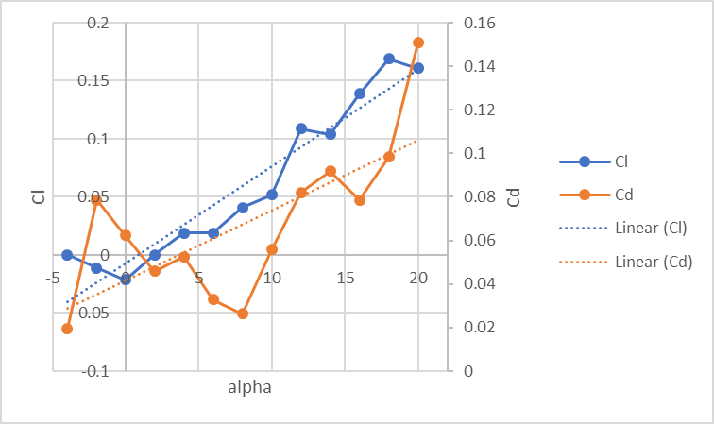****Table 2- Clean Wing data*

Figure 16- clean wing plotted data

|  |  |  |
| --- | --- | --- |
| **Clean** | **CL** | **CD** |
| offset | 0.000 | 0.000 |
| -4 | -0.011 | 0.020 |
| -2 | -0.021 | 0.079 |
| 0 | 0.000 | 0.062 |
| 2 | 0.019 | 0.046 |
| 4 | 0.019 | 0.052 |
| 6 | 0.041 | 0.033 |
| 8 | 0.052 | 0.026 |
| 10 | 0.109 | 0.056 |
| 12 | 0.104 | 0.082 |
| 14 | 0.139 | 0.092 |
| 16 | 0.169 | 0.079 |
| 18 | 0.161 | 0.098 |
| 20 | 0.199 | 0.151 |

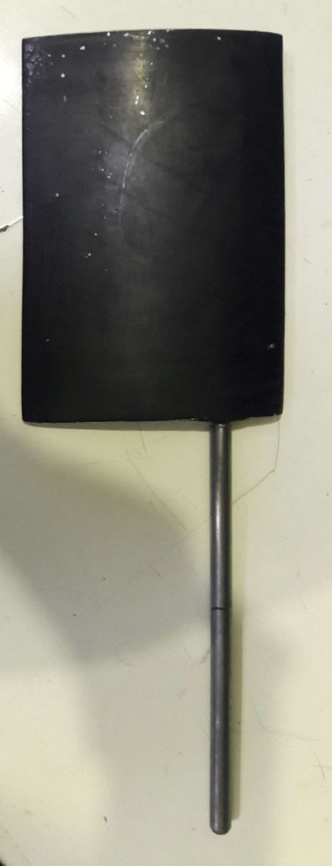

*Figure 17- Clean Wing*

## Wing with one-sided winglet

**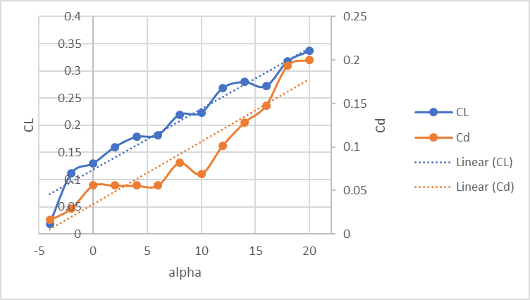***Table 3- wing with one-sided winglet data*

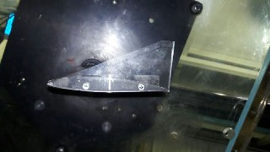

Figure 18-one-sided winglet

Figure 19- one-sided winglet plotted data

|  |  |  |
| --- | --- | --- |
| **Clean** | **CL** | **CD** |
| offset | 0 | 0 |
| -4 | 0.019 | 0.016 |
| -2 | 0.112 | 0.030 |
| 0 | 0.130 | 0.056 |
| 2 | 0.160 | 0.056 |
| 4 | 0.179 | 0.056 |
| 6 | 0.182 | 0.056 |
| 8 | 0.220 | 0.082 |
| 10 | 0.223 | 0.069 |
| 12 | 0.269 | 0.102 |
| 14 | 0.280 | 0.128 |
| 16 | 0.272 | 0.148 |
| 18 | 0.318 | 0.193 |
| 20 | 0.337 | 0.200 |

The experiment is done with the wing shown in the figure 4 and 5 that has a winglet, added at the root of it. As expected, the lift coefficient grows with the increase in the aoa by one degree per each step. It is also seen that the drag coefficient increases with the increase in aoa. The winglet which is shown is a triangle-type winglet and one-sided and is expected to increase the lift coefficient but to reduce the drag induced coefficient.

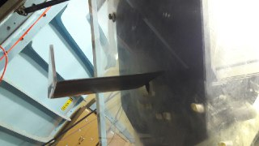

Figure 20- wing with one-sided winglet

## Wing with double-sided winglet

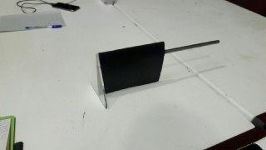*Table 4- wing with double-sided winglet data*

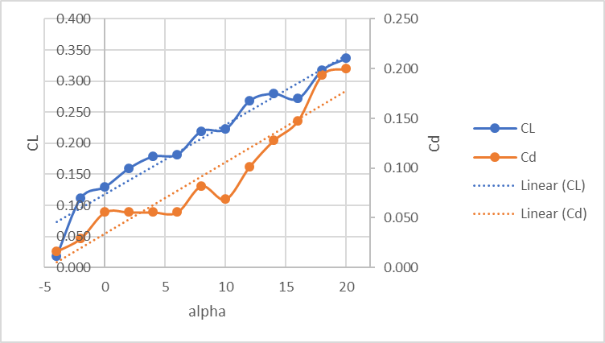

Figure 21- double-sided winglet plotted data

|  |  |  |
| --- | --- | --- |
| **Clean** | **CL** | **CD** |
| offset | 0.000 | 0.000 |
| -4 | 0.000 | 0.033 |
| -2 | 0.065 | 0.043 |
| 0 | 0.095 | 0.033 |
| 2 | 0.133 | 0.046 |
| 4 | 0.155 | 0.020 |
| 6 | 0.193 | 0.052 |
| 8 | 0.204 | 0.066 |
| 10 | 0.207 | 0.059 |
| 12 | 0.253 | 0.089 |
| 14 | 0.264 | 0.111 |
| 16 | 0.283 | 0.131 |
| 18 | 0.313 | 0.171 |
| 20 | 0.302 | 0.197 |

Figure 22-wing with double-sided winglet

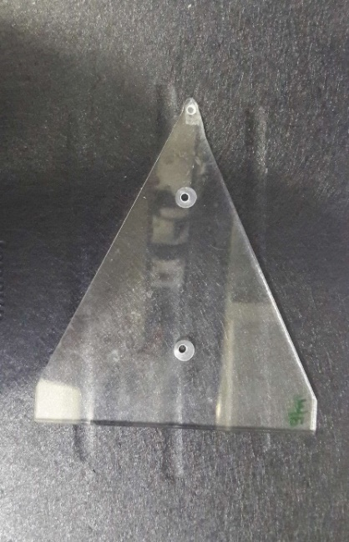

Figure 23-double-sided winglet

The second experiment on a wing with a winglet included is done with a winglet of trinangle-type but double-sided. This winglet is also expected to increase the lift coefficient and to reduce darg coefficient by decreasing the tip vortices at the tip of the wing to reduce induced drag.

## Comparison and discussion

*Table 5 - all data comparison*

|  |  |  |  |  |  |  |  |  |  |
| --- | --- | --- | --- | --- | --- | --- | --- | --- | --- |
| Alpha | Clean | | | W1 | | | W5 | | |
| **Cl** | **CD** | **Cl/Cd** | **Cl2** | **CD2** | **Cl/Cd2** | **Cl4** | **CD5** | **Cl/Cd5** |
| offset | 0.000 | 0.100 | 0.000 | 0.000 | 0.100 | 0.000 | 0.000 | 0.100 | 0.000 |
| -4 | -0.011 | 0.020 | -0.559 | 0.019 | 0.016 | 1.157 | 0.000 | 0.033 | 0.000 |
| -2 | -0.021 | 0.079 | -0.273 | 0.112 | 0.030 | 3.793 | 0.065 | 0.043 | 1.522 |
| 0 | 0.000 | 0.062 | 0.000 | 0.130 | 0.056 | 2.328 | 0.095 | 0.033 | 2.893 |
| 2 | 0.019 | 0.046 | 0.413 | 0.160 | 0.056 | 2.866 | 0.133 | 0.046 | 2.893 |
| 4 | 0.019 | 0.052 | 0.362 | 0.179 | 0.056 | 3.207 | 0.155 | 0.049 | 3.148 |
| 6 | 0.041 | 0.033 | 1.250 | 0.182 | 0.056 | 3.261 | 0.193 | 0.052 | 3.675 |
| 8 | 0.052 | 0.026 | 1.982 | 0.220 | 0.082 | 2.680 | 0.204 | 0.066 | 3.107 |
| 10 | 0.109 | 0.056 | 1.954 | 0.223 | 0.069 | 3.235 | 0.207 | 0.059 | 3.504 |
| 12 | 0.104 | 0.082 | 1.268 | 0.269 | 0.102 | 2.643 | 0.253 | 0.089 | 2.855 |
| 14 | 0.139 | 0.092 | 1.513 | 0.280 | 0.128 | 2.187 | 0.264 | 0.111 | 2.366 |
| 16 | 0.169 | 0.079 | 2.146 | 0.272 | 0.148 | 1.841 | 0.283 | 0.131 | 2.156 |
| 18 | 0.161 | 0.098 | 1.636 | 0.318 | 0.193 | 1.642 | 0.313 | 0.171 | 1.834 |
| 20 | 0.199 | 0.151 | 1.318 | 0.337 | 0.200 | 1.683 | 0.302 | 0.197 | 1.533 |

Figure 24- Cl-alpha comparison

Figure 26-- Cd-alpha comparison

Figure 27-CL/Cd-alpha comparison

The results of each experiment are presented. Using data gathered from the experiment with the clean wing as a reference it was expected from winglets that were added to the tip of the wing to increase the lift coefficient and more importantly to decrease in drag coefficient of induced type.

Figure 73 compares the results of the lift coefficients for the three cases. A jump is obviously detected in lift coefficients of the clean wing and those two cases which have winglet and the winglets added to the wing tip in each case has increased the lift coefficient for about 0.14 in maximum. A notable result is that the two types of winglet seem to affect the lift coefficient in a same manner and for about same amounts.

Figure 74 compares the drag coefficient results. It was expected to find out a decrease in drag coefficient by adding winglets at the wing tip but results show that inserting winglet at the tip of the wing, increases the drag coefficient and as it can be seen in the results, the one-sided type of winglet increased the drag coefficient more than the double-sided type. Actually, the expected decrease in drag coefficient is predicted for the induced part of the drag coefficient based on the aerodynamic behavior of the fluid at the tip of the wing and this result may be found out by separating the types drag forces which must be done in further investigations. Also, the more increase of the drag coefficient resulted from the one-sided winglet in comparison with the double-sided one may be related to the nonsymmetric shape of the one-sided winglet and the symmetric shape of the double-sided one.

Figure 75 also gives an overall comparison for the ratio of the lift coefficient and the drag coefficient and brings this result that for all cases of test, there can be found an angle with the maximum amount of lift to drag ratio and it also is seen that winglets lag this angle of maximum lift to drag ratio with respect to the clean wing and again this lag is more for the nonsymmetric winglet than the symmetric one.

As a conclusion, adding winglets at the tip of a wing increases the amount of lift coefficient but also increases the total drag coefficient. A wing with winglets reaches its maximum lift to drag ratio at lower angles of attack with respect to a wing without winglets.